**Problem Statement:** You work for XYZ Corporation.

Their application requires a SQL service that can store data which can be retrieved if required. Implement a suitable RDS engine for the same.

**While migrating, you are asked to perform the following tasks:**

1. Create a MariaDB Engine based RDS Database.

2. Connect to the DB using the following ways: a. SQL Client for Windows b. Linux based EC2 Instance

Created a MariaDB Engine based RDS Database.

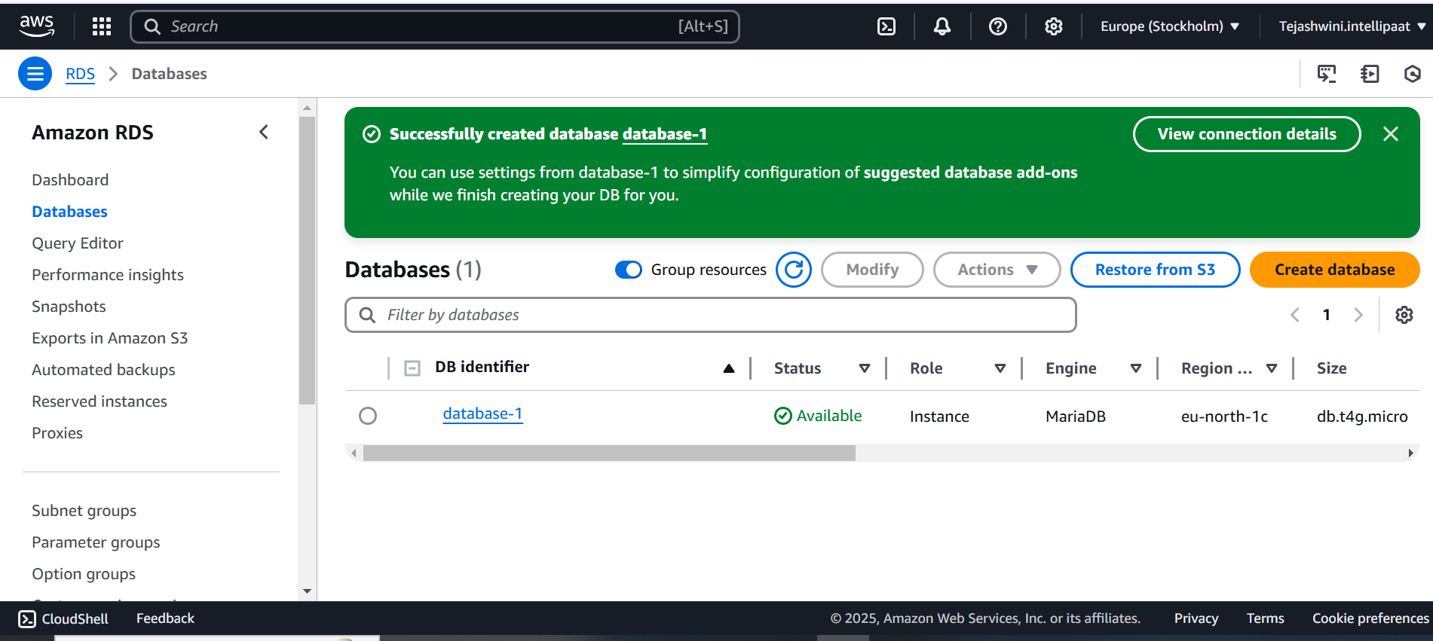

Ensure security group type is all traffic and source is anywhere IPv4

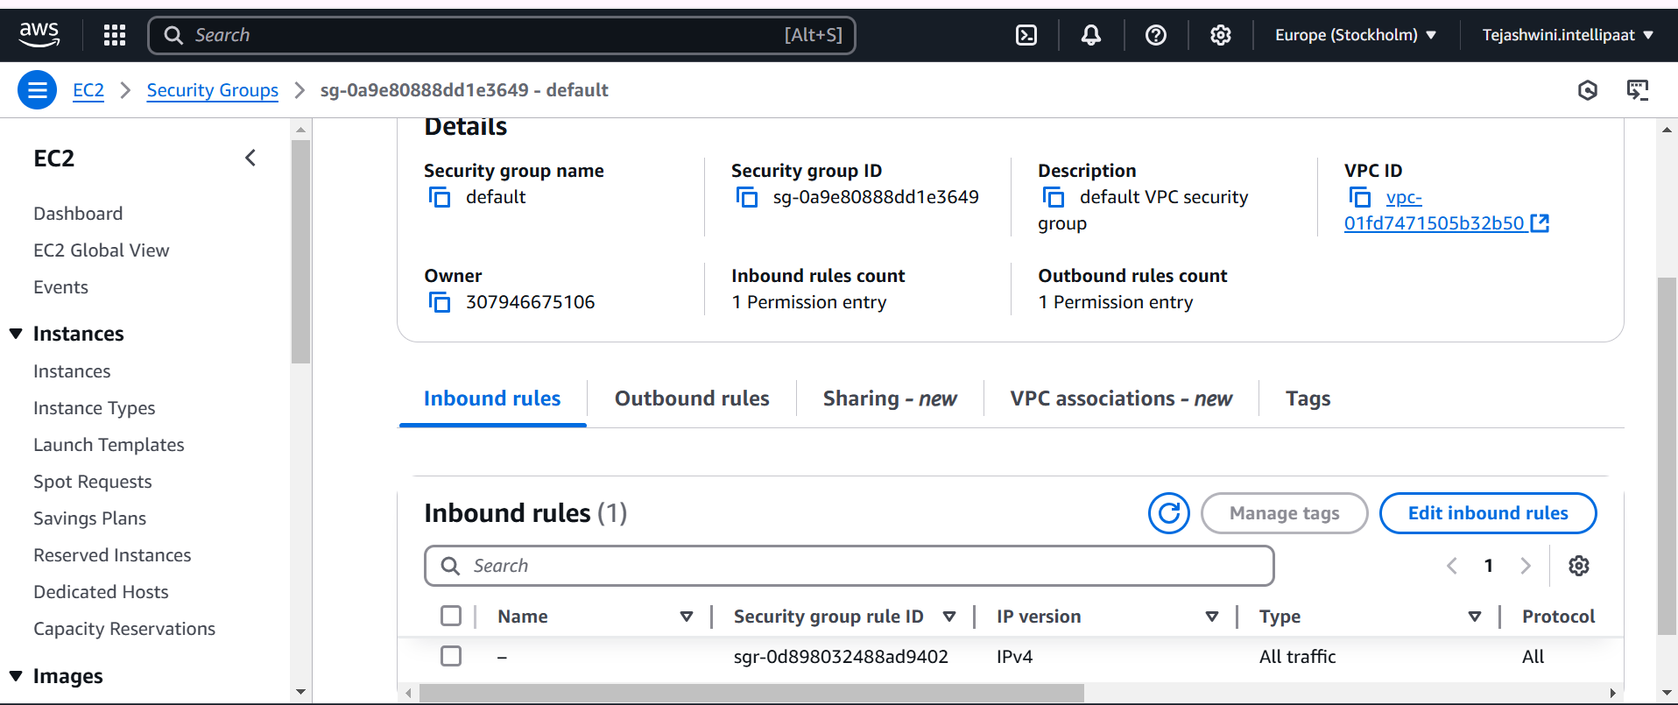

Created instance using linux based machine **Ubuntu**

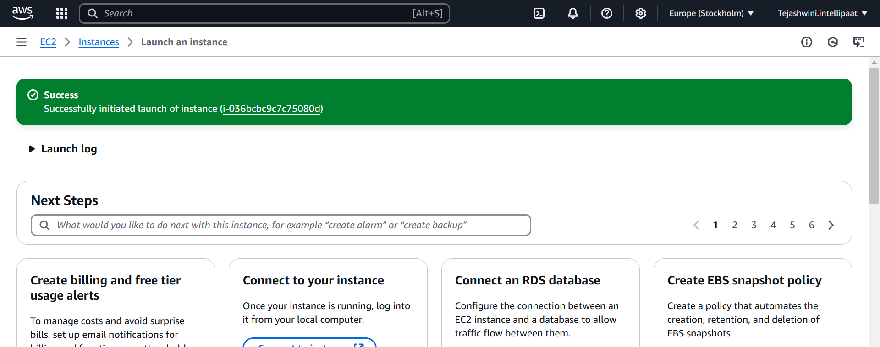

Here are the commands used to connect to database

sudo su

sudo apt-get update

sudo apt install mysql-server

sudo apt install mysql-client

**connection command:** mysql -h <endpoint> -u <username> -p click enter

enter password<password>

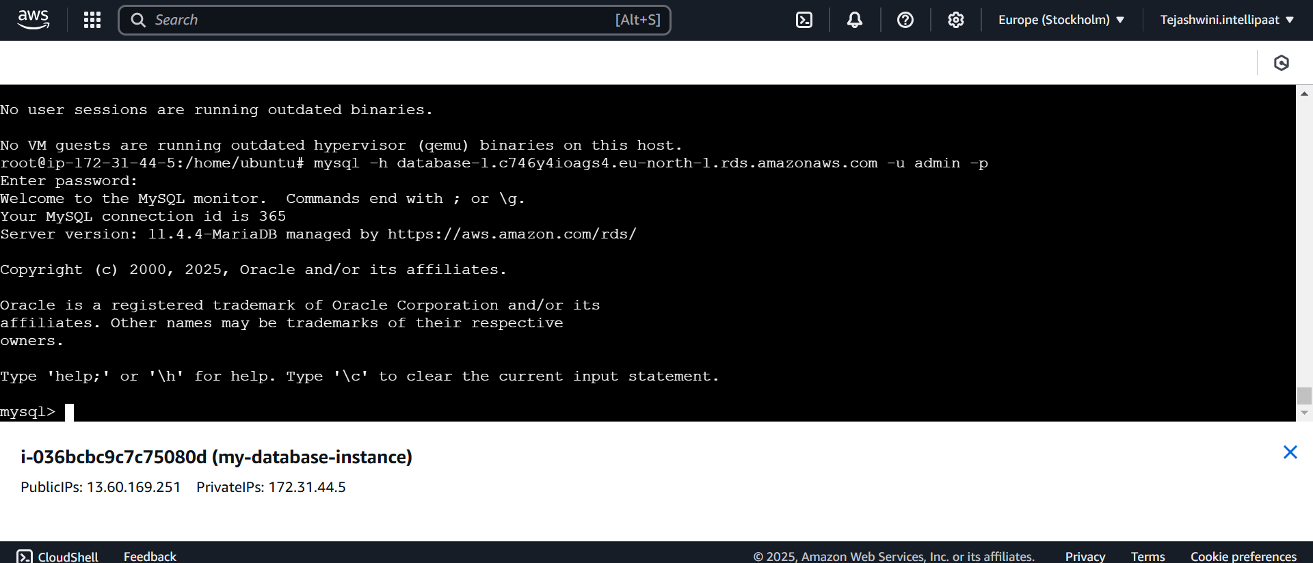

show databases; (you will find the database created)

use <database name>; (database will be changed)

show tables; (to see the existing tables)

create table data <name variables characters (50), email variables characters (50));

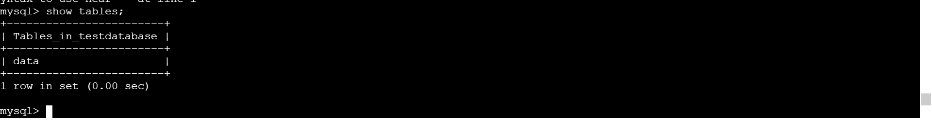

Download and install xampp <https://www.apachefriends.org/download_success.html>

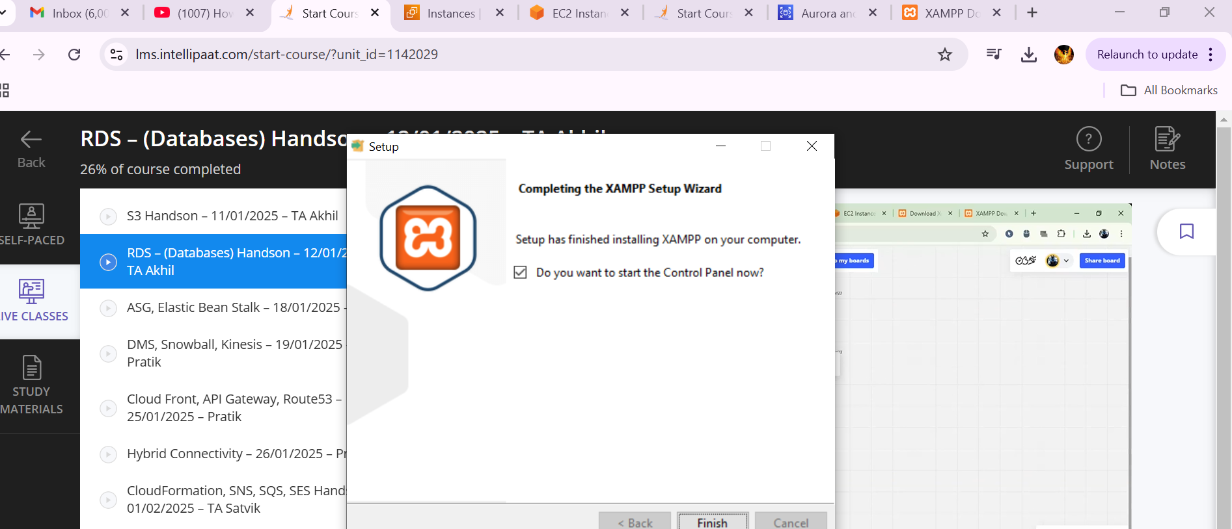

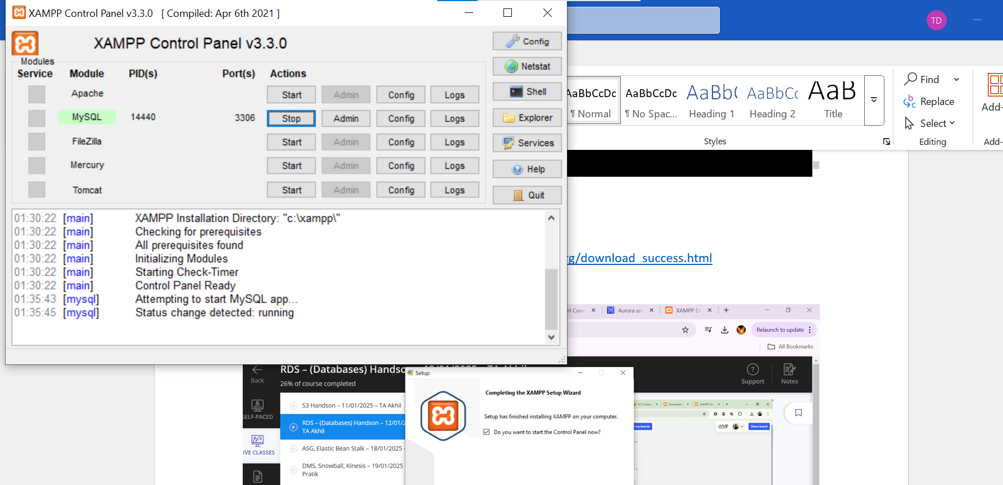

**Commands used to connect database in windows are below**

Mysql -h <endpoint> -u <username> -p

enter<password>

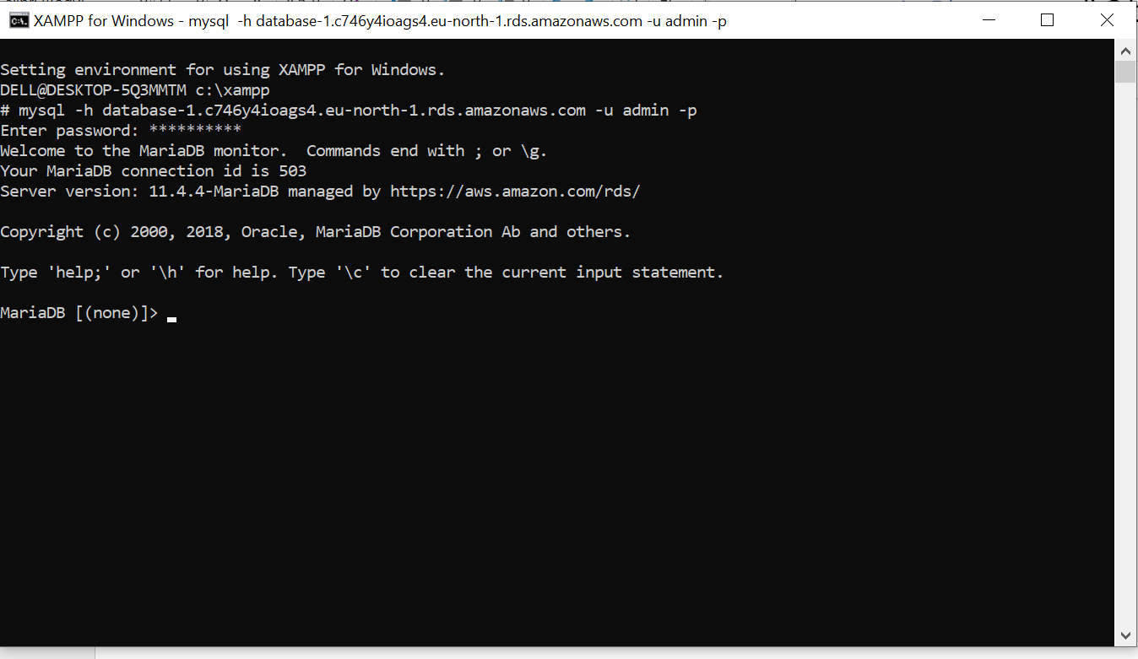

Show database;

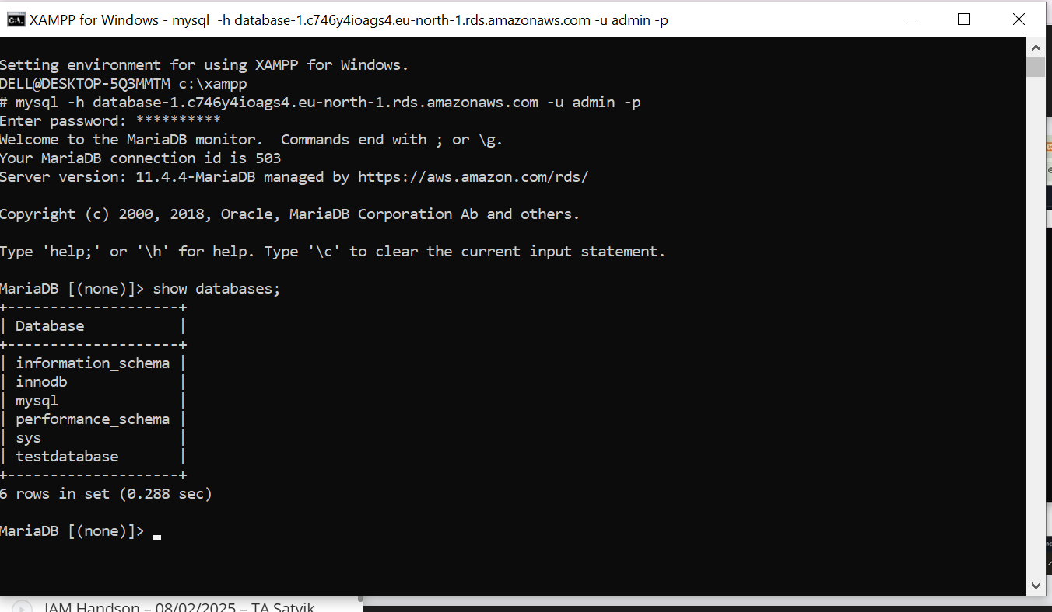

**Problem Statement:**

You work for XYZ Corporation. Their application requires a database service that can store data which can be retrieved if required. Implement a suitable service for the same.

**While migrating, you are asked to perform the following tasks:**

1. Create a DynamoDB table with partition key as ID.

2. Add 5 items to the DynamoDB table.

3. Take backup and delete the table.

Created a DynamoDB table with partition key as ID.

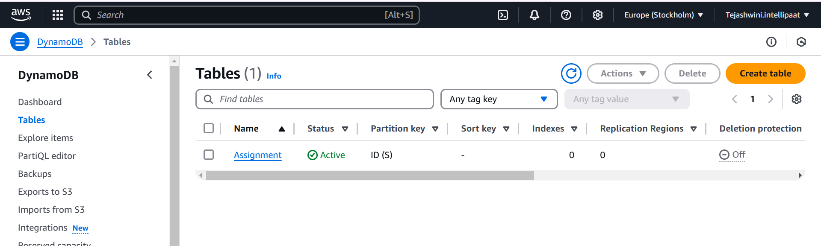

Created 5 items to the table

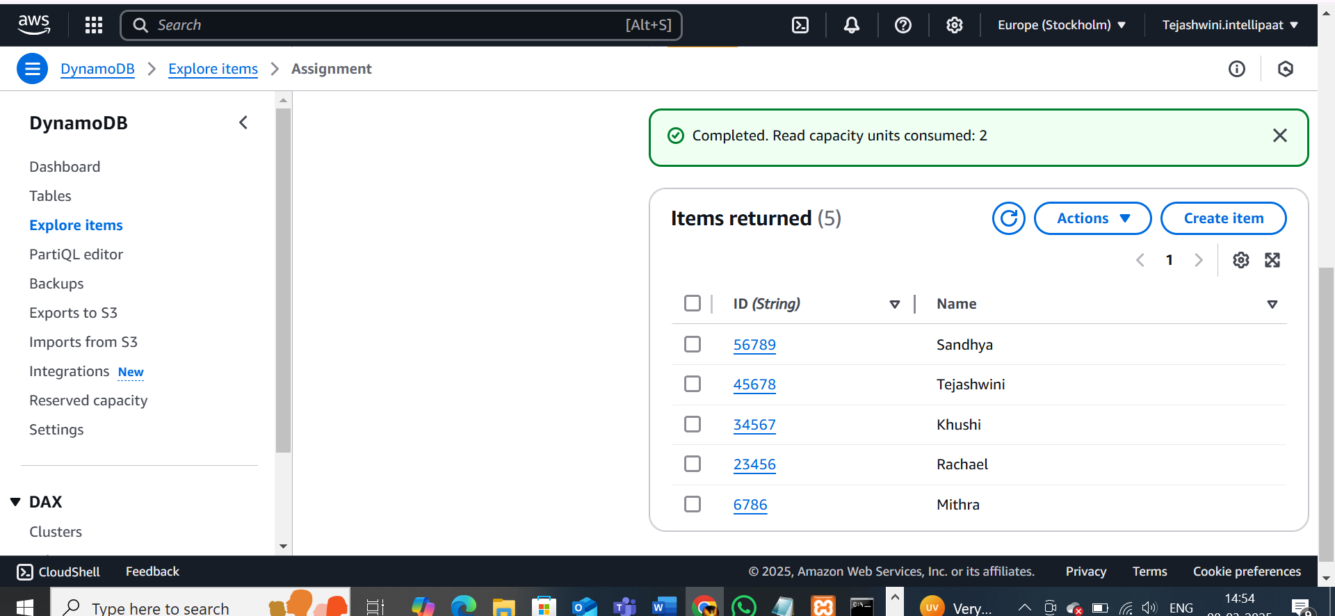

Go to the table – click on backup - click on create back up – click on demand backup

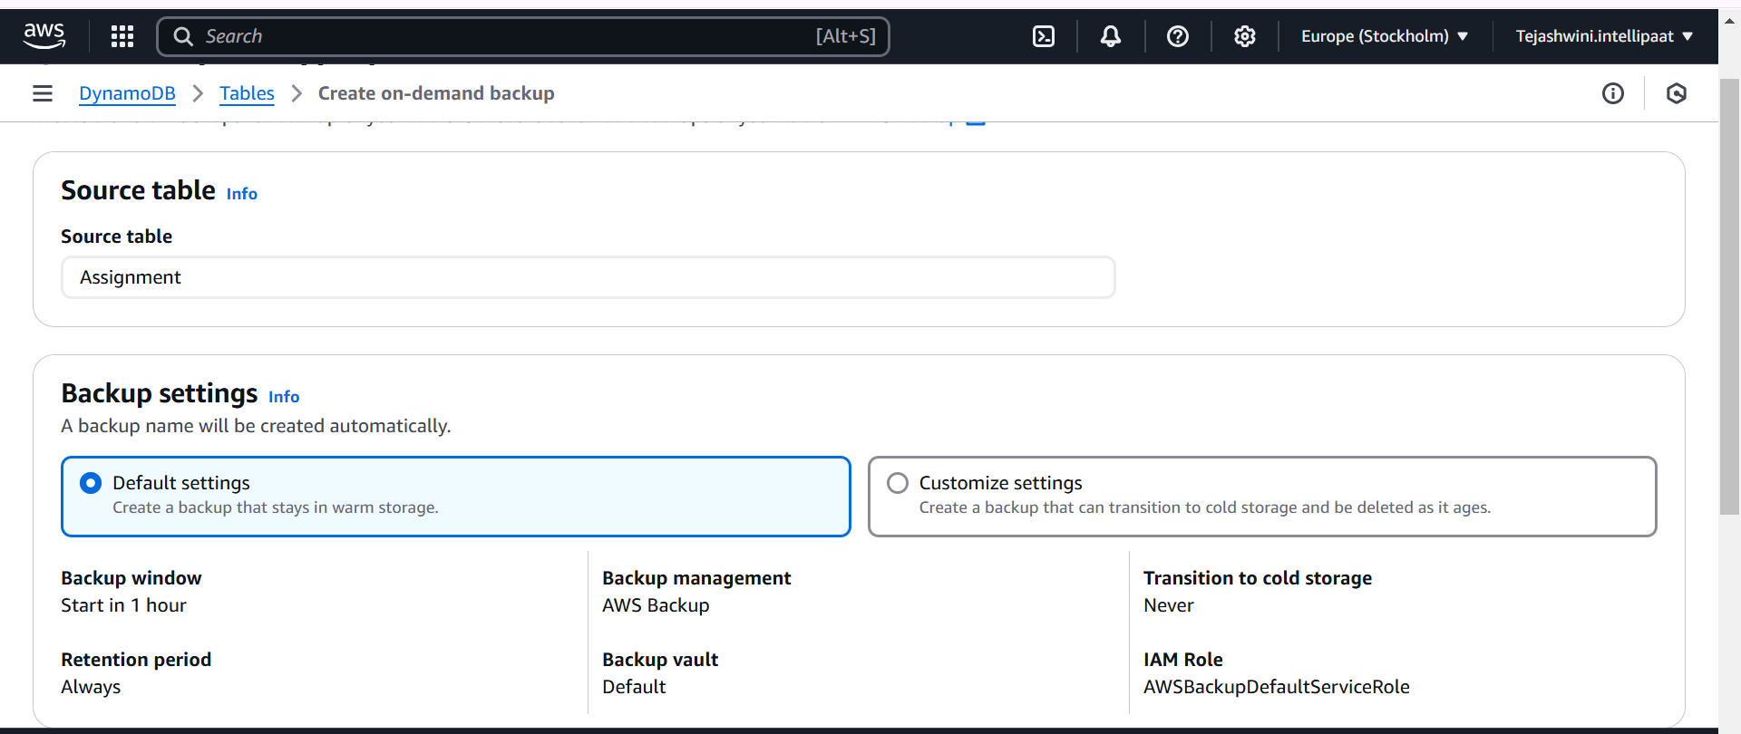

Created a backup for table Assignment

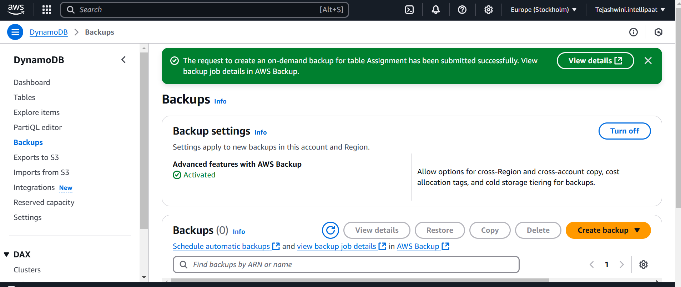

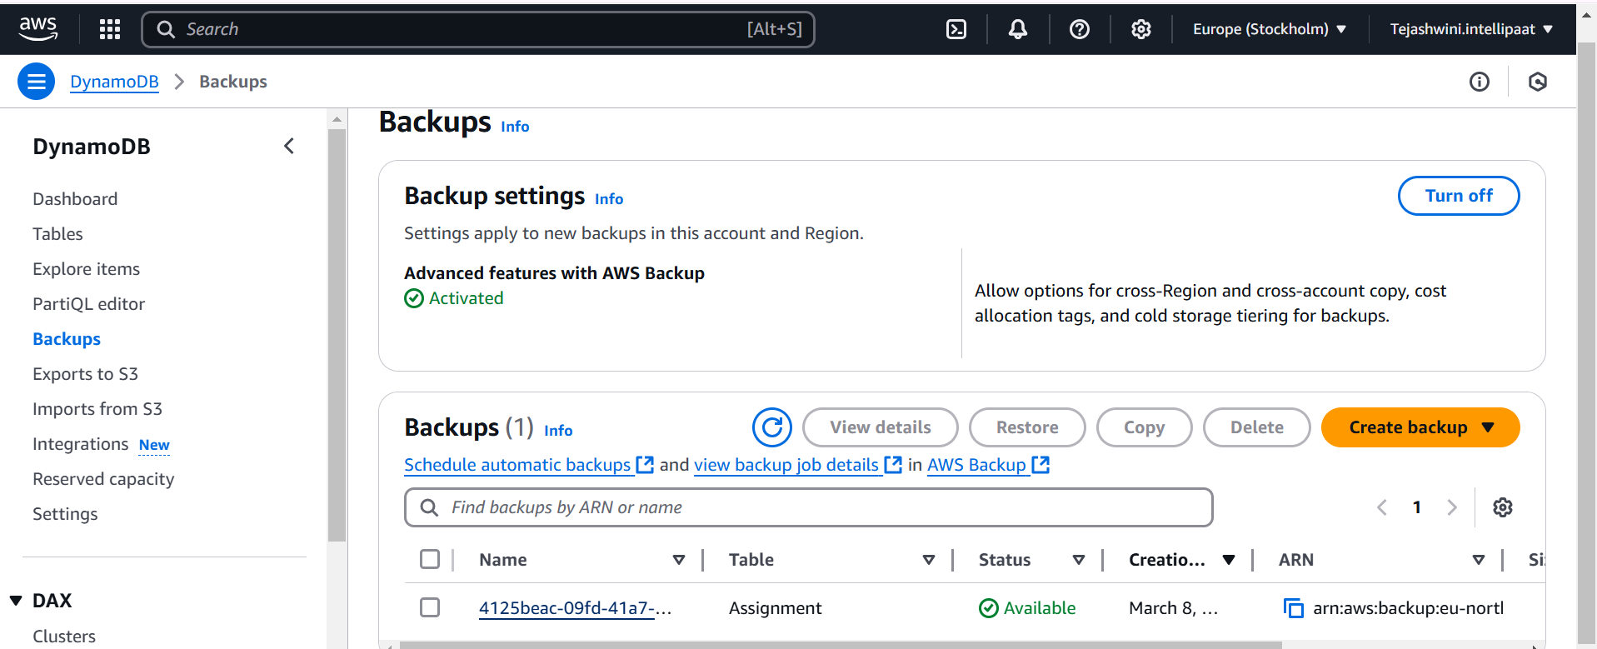

Deleted the table Assignment

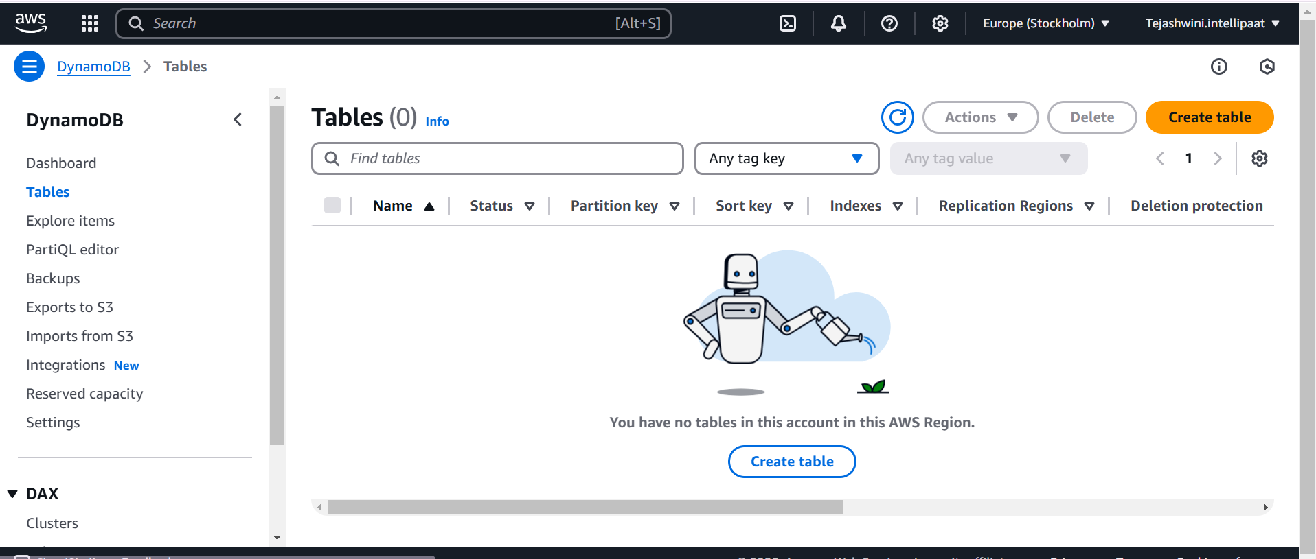

**Problem Statement:**

You work for XYZ Corporation. Their application requires a SQL service that can store data which can be retrieved if required. Implement a suitable RDS engine for the same.

**While migrating, you are asked to perform the following tasks:**

1. Create an AuroraDB Engine based RDS Database.

2. Create 2 Read Replicas in different availability zones for better infrastructure availability.

Create an AuroraDB Engine based RDS Database.

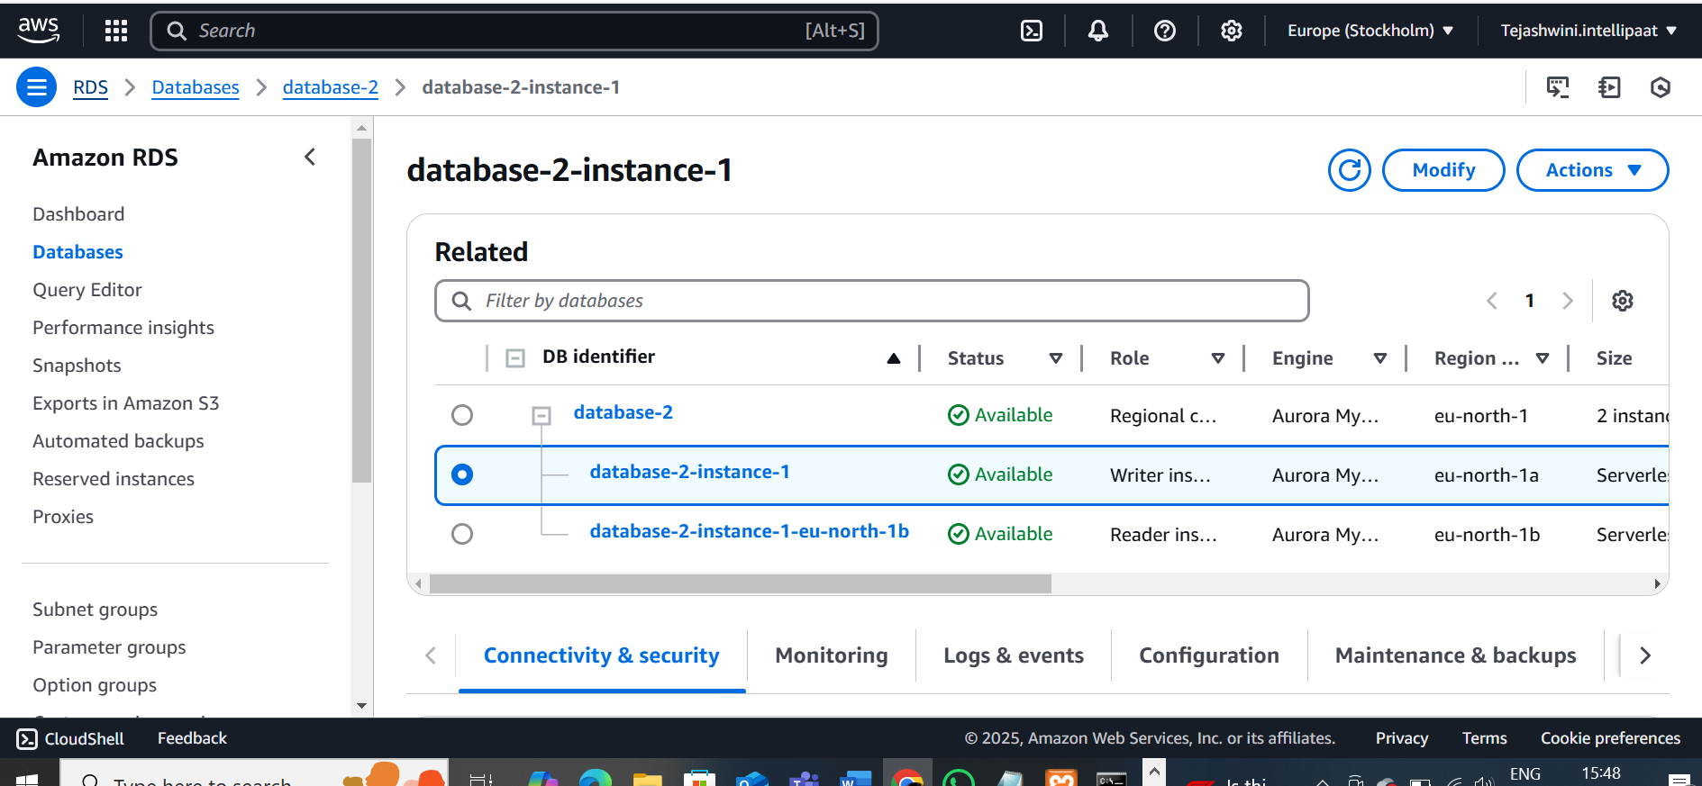

Created 2 read replica in different zones

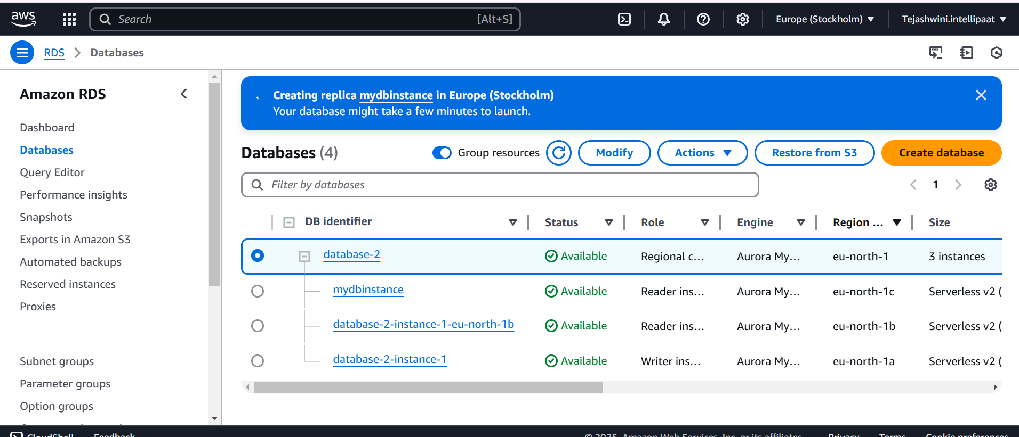

**Problem Statement:**

You work for XYZ Corporation. Their application requires a database service that can store data which can be retrieved if required. Implement suitable service for the same.

**While migrating, you are asked to perform the following tasks:**

1. Create a Redshift data warehouse.

2. Using the query editor: a. Load some data b. Query the data

Create a redshift cluster

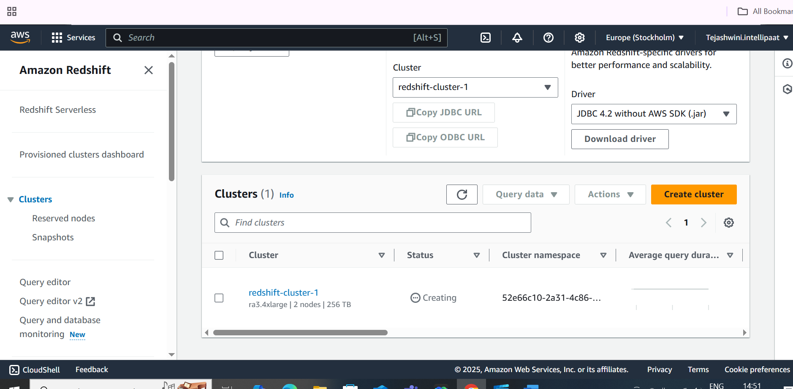

Upload data from S3 and Connect to the database using query editor V2

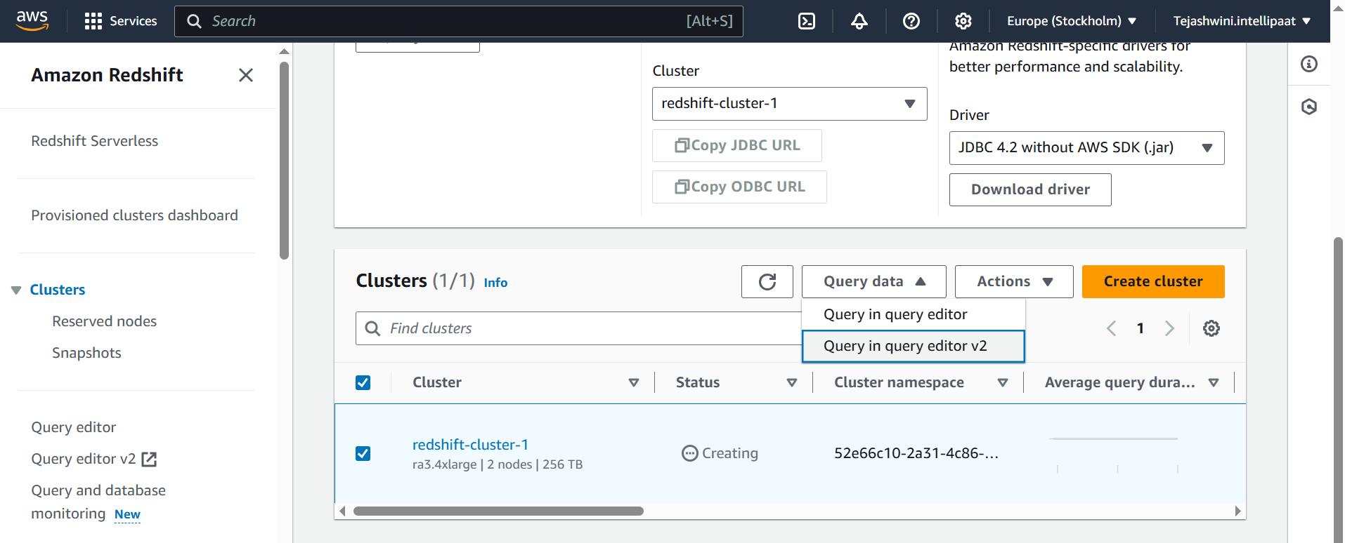

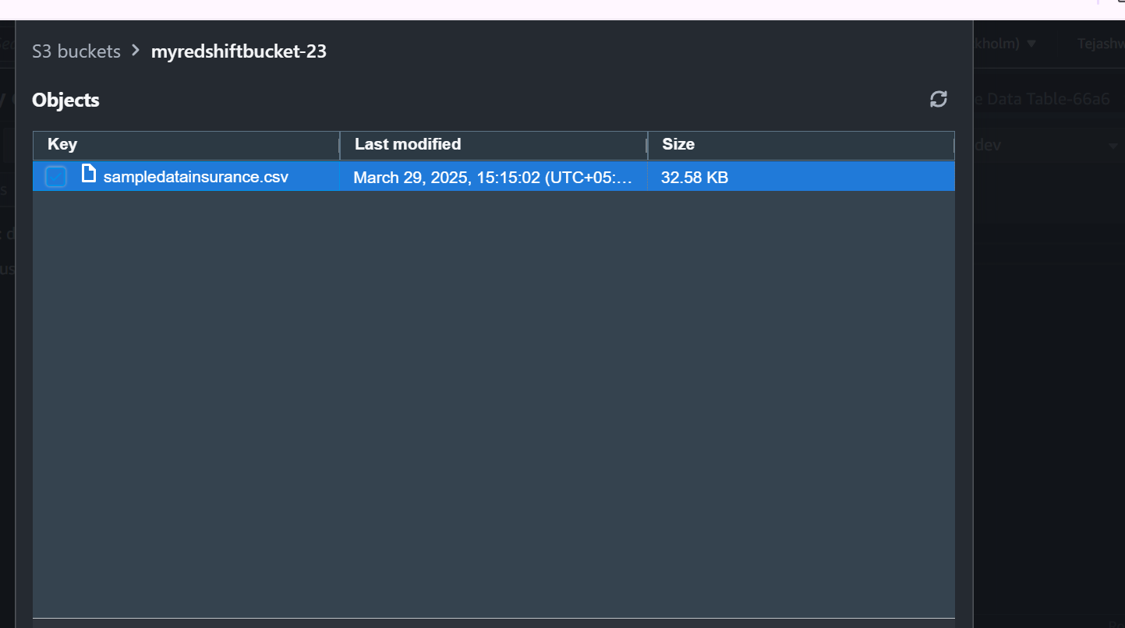

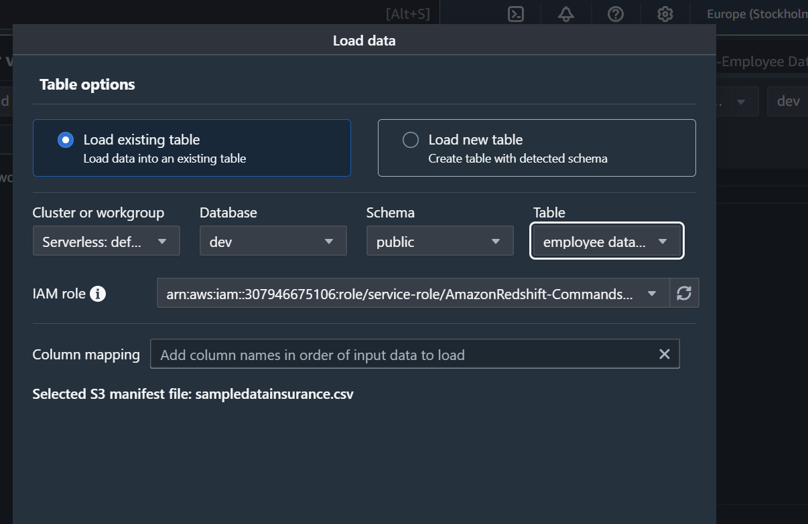

Create a Table

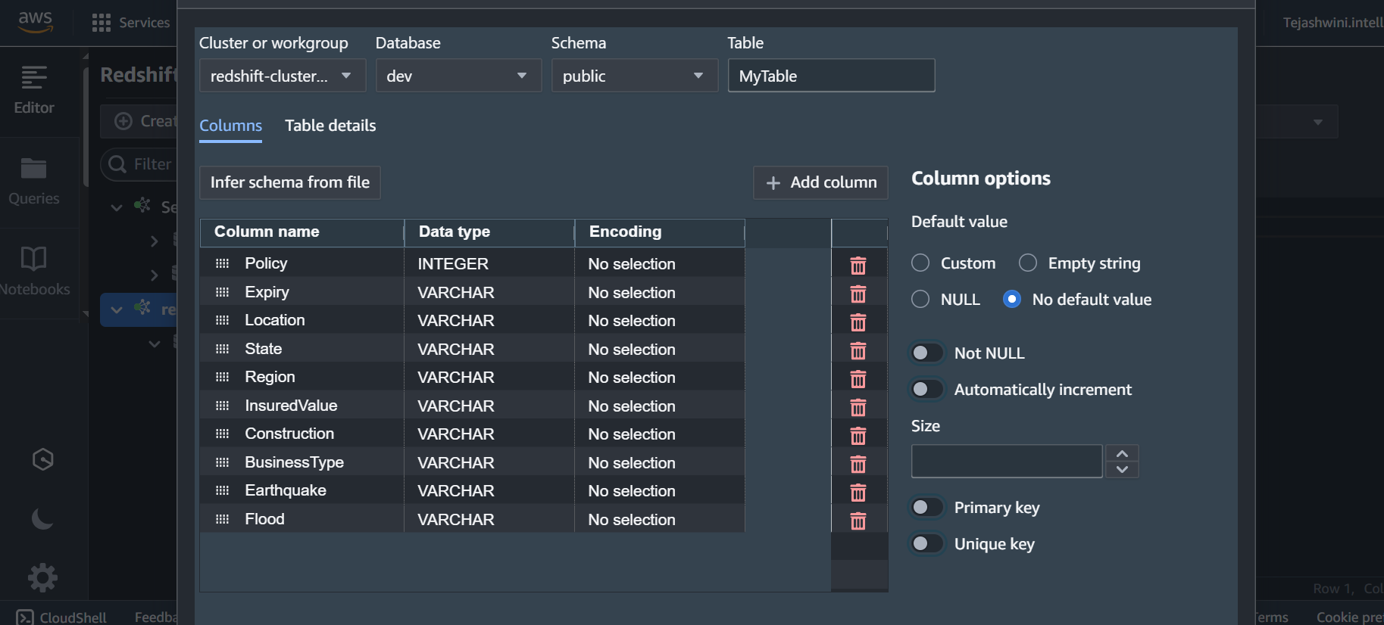

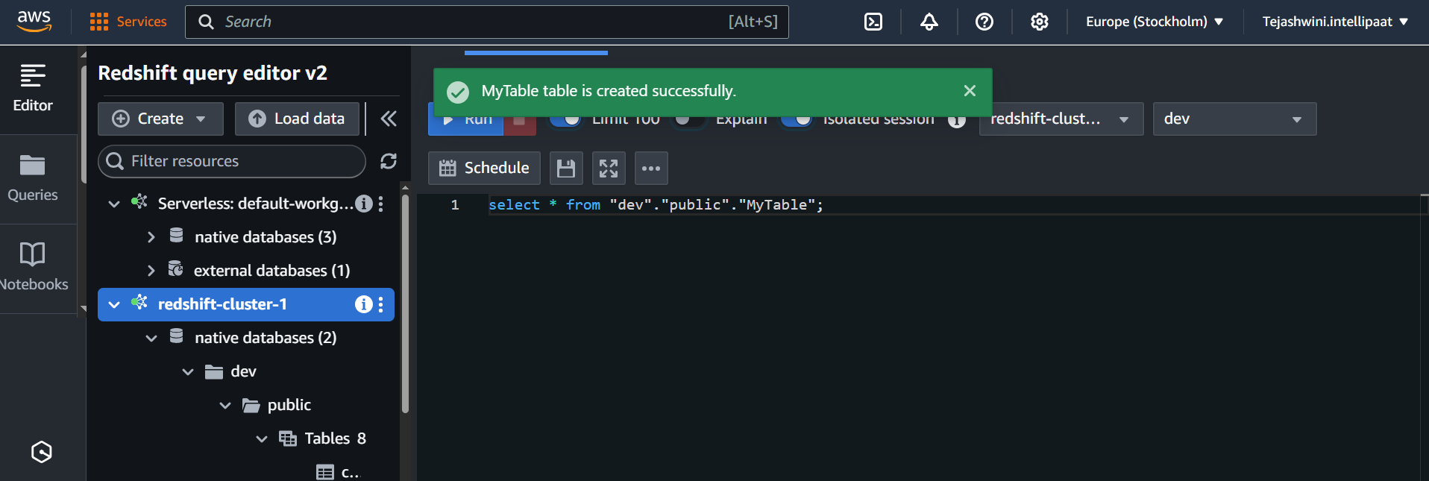

Load data to display the table created

